Test Cases for Milford Bay Cinema Seat Booking System

by Xiaofeng Lin (1487467) and Jeffrey Zhan

Requirement to test | Test Data Input | Expected Outcomes | Actual Outcomes
- Load the navigation page | Open the navigation page | 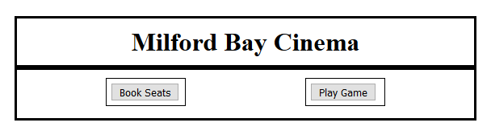
- Load the Box Office page | Click on the “Book Seats” button | 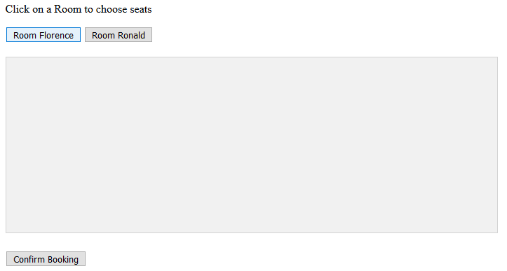
- Load the layout of Room Florence | Click on the “Room Florence” button | 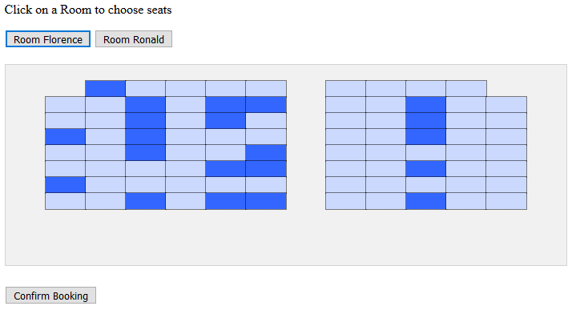
- Load the layout of Room Ronald | Click on the “Room Ronald” button | 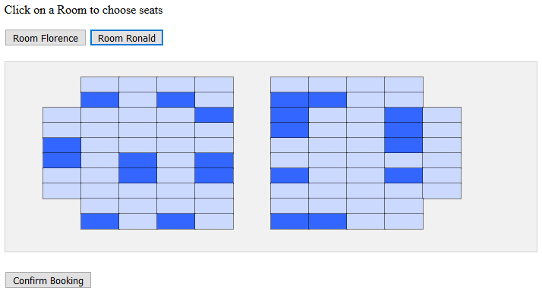
- Deny choosing booked seats | Click on a booked seat, which is dark blue | A window pops up, warning the user “You cannot choose a booked seat” | 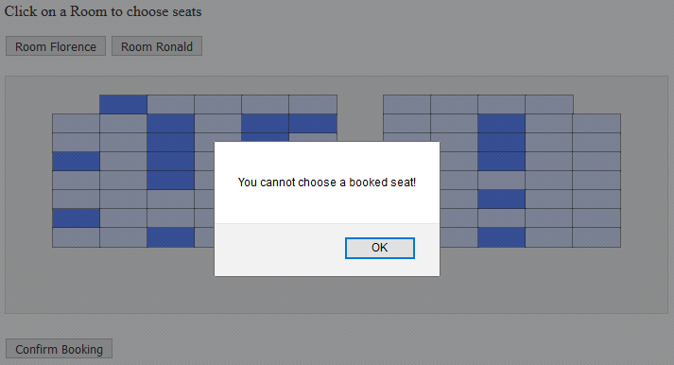
- Choose vacant seats. Show the row and seat numbers and the individual and total prices | Click on vacant seats, which are light blue | The chosen seats go green, the row and seat numbers as well as the individual and total prices are shown in a table above the the “Confirm Booking” button. | 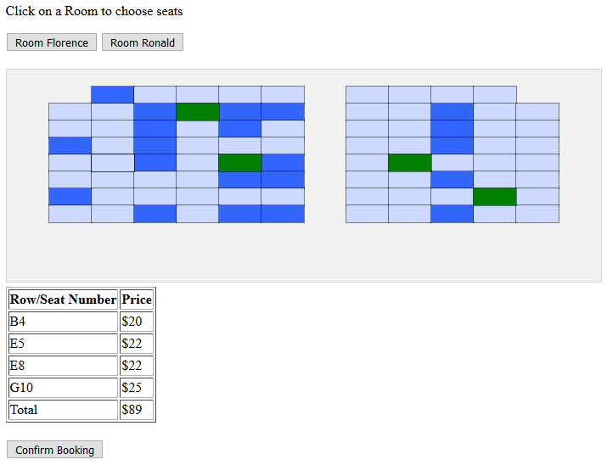
- Cancel chosen seats | Click on chosen seats, which are green | The green seats, which have been clicked the second time, turn back to light blue, and the row and seat numbers as well as the individual and total prices disappear. | 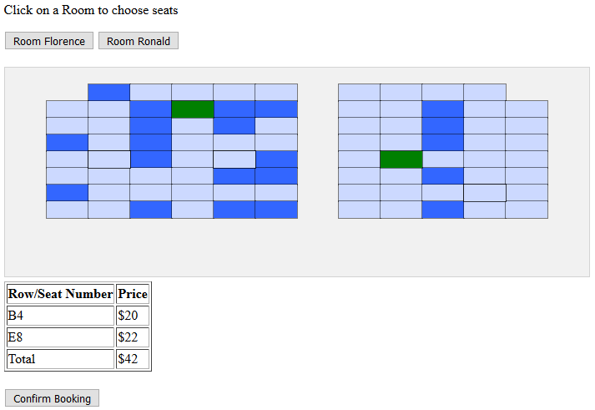
- Confirm booking | Click on the “Confirm Booking” button after choosing seats | The green seats, which represent the chosen ones, go dark blue, which represents booked seats. A info window pops up, telling the user that the booking is confirmed. | 